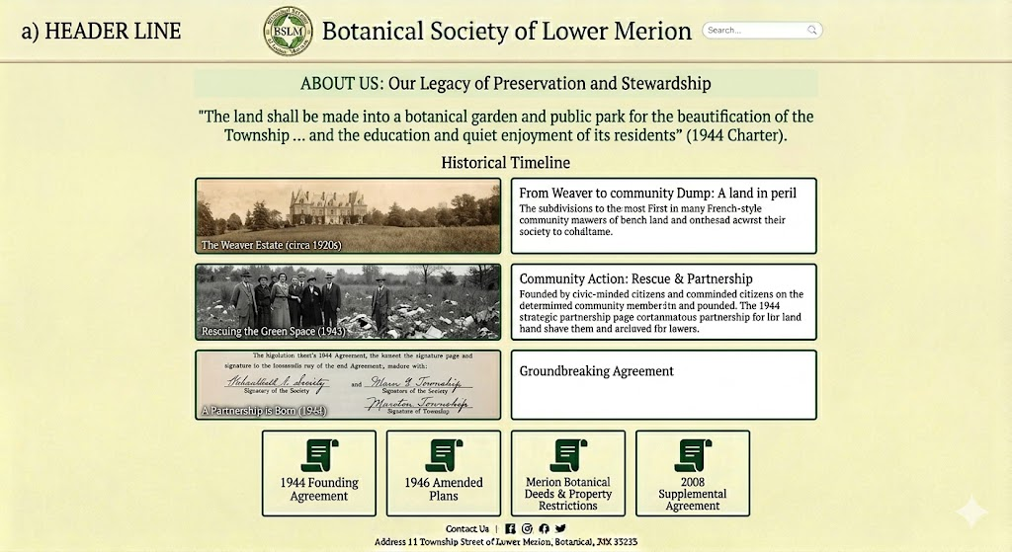

SUPPOSEDLY, THIS ALL THE CODE NEED FOR A SQUARE SPACE DEVELOPER TO CREATE OUR 1ST BRANCH – ABOUT US (HISTORY)

To provide a Square Space developer with the necessary tools to build the About Us branch, I have outlined the custom code, content logic, and document architecture based on your historical files.

1. Page Architecture & Logic
This page uses a Scroll-Point Logic. As users scroll, the timeline elements should fade in to reflect the "Legacy of Preservation".

Primary Logic: The page is divided into a Hero Narrative (Top), a Chronological Timeline (Middle), and a Document Repository (Bottom).
+1

Data Flow: The "Digital Vault" icons at the bottom must link directly to PDF assets hosted in the Squarespace site library.
+1

2. Squarespace Custom CSS (Visual Styling)
The developer should add this to Design > Custom CSS to ensure the About Us page maintains the "aged paper" and "botanical" aesthetic from our mockup.

CSS
/* About Us Content Container */
.about-history-section {
padding: 60px 10% !important;
line-height: 1.6;
}

/* Mission Statement Quote */
.about-mission-statement {
font-size: 1.4rem;
font-style: italic;
color: #2D4F1E;
text-align: center;
border-left: 4px solid #D8C8A6;
margin: 40px 0;
padding: 20px;
}

/* Timeline Image Blocks */
.timeline-block {
display: flex;
gap: 30px;
margin-bottom: 50px;
align-items: center;
}

.timeline-image {
flex: 1;
border: 1px solid #D8C8A6;
box-shadow: 5px 5px 15px rgba(0,0,0,0.05);
}

/* Document Icon Grid */
.document-vault-grid {
display: grid;
grid-template-columns: repeat(auto-fit, minmax(150px, 1fr));
gap: 20px;
text-align: center;
margin-top: 50px;
}
3. Content Data for the Developer
The developer will need to input this specific text from your documents into the Squarespace blocks:

The Mission: "The land shall be made into a botanical garden and public park for the beautification of the Township... and the education and quiet enjoyment of its residents".
+1

Timeline Point 1 (1920s): The Weaver Estate. Mention the 16-acre meadow that survived the mansion subdivision.

Timeline Point 2 (1943): Community Rescue. Civic-minded citizens raised $17,000 to save the land from being used as a dump.

Timeline Point 3 (1944): The Agreement. The Township and Society joined forces to purchase the land for $15,000.

4. Document Vault Asset Mapping
The developer must create a "Digital Vault" using Image Blocks (with the scroll icon) and link them to the following files you provided:

Document Title Action Link
1944 Founding Agreement Link to 1944_Agreement.pdf
1946 Amended Plans Link to 1946_Agreement.pdf
Property Deeds & Restrictions Link to Merion_Botanical_Deeds.pdf
2008 Supplemental Agreement Link to Merion_Botantical_Park_Agreement_11-20-08.pdf
Would you like to continue to the next branch icon, "What We Do" (Charter & Stewardship), or refine the document list for this archive?

